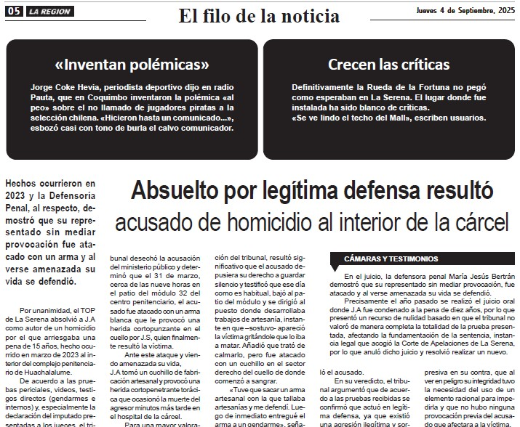

LINK NOTA DIARIO LA REGION:
https://map.conectamedia.cl/index.php/clippingNews/view?id=49317068

